Cleaning up the Great Lakes

Intro: The Cleaning up the Great Lakes project is based off of an important topic learned earlier in the year in which we calculated the rate of change of a pollutant through inflow and outflow of liquid in different shapes. We are using the knowledge of differential equations and how to manipulate them to try to figure out how long it would take to decrease the pollutant in the lakes by a certain percentage. Matlab will be heavily utilized in this project to carryout the calculations.

Part 1: For the first step we calculated how long it would be expected to take to flush all the pollution out of the Great Lakes. We calculated the time it would take to remove all the pollution from the lakes by multiplying the size of each great lake in $mi^{3}$by the outflow rate of the water. The results of the calculations are based on the volume of each lake individually and each

Lake Superior:
$2929 mi^{3}*1 year/16 mi^{3}=183.06 years$
Lake Michigan:
$1145 mi^{3 }*1 year/37 mi^{3}=30.95 years$
Lake Huron:
$$884 mi^{3}*1 year/75 mi^{3}=11.79 years$$
Lake Erie:
$114mi^{3} * 1 year/114 mi^{3 }=1.18 years$
Lake Ontario:
$389 mi^{3}* 1 year/111 mi^{3}=3.5 years$

Part 2:
In part 2 we are assuming that each lake is a separate tank and each tank only has clean water flowing in. Using this approach we calculated how long it would take each individual lake to reach a point of 50% pollutant and 5% pollutant. In this case t is in years.
In step two we obtained a better estimate by assuming that only fresh water is flowing in. This approach was used to calculate how long it would take to remove 50% of the pollution and how long it would take to remove 95% of the pollution in the Great Lakes. We calculated the integral based on the initial equation we came up with and used the volume and outflow rate of each lake to calculate the time it would take to remove the pollution from the lakes.

Lake Superior:
50%=> $ds/dt= (-16/2929)*S$ $∫ds/S=∫(-16/2929)*dt$ $ln(t)= -16t/2929+C1$ $x1(t)=C1e^{(-16t/2929)}$ $x1(t)=.5*C1$ $.5C1=Ce^{(-16t/2929)}$ $t=ln(.5)*(-2929/16)$ $t=127 years$
5%=> $x1(t2)=.05*C1$ $.05C1=C1e^{(-16t/2929t2)}$ $t2=ln(.05)*(-2929/16)$ $t2=548.41 years$
Lake Michigan:

50%=> $ds/dt= (-37/1145)*S$ $∫ds/S=∫(-37/1145)*dt$ $ln(t)= -37t/1145+C1$ $x1(t)=C1e^{(-37t/1145)}$ $x1(t)=.5*C1$ $.5C1=Ce^{(-37t/1145)}$ $t=ln(.5)*(-1145/37)$ $t=21.4 years$
5%=> $x1(t2)=.05*C1$ $.05C1=C1e^{(-37t2/1145)}$ $t2=ln(.05)*(-1145/37)$ $t2=92.71 years$
Lake Huron:
$50\%=>ds/dt= (-75/884)*S$ $∫ds/S=∫(-75/884)*dt$ $ln(t)= -75/884+C1$
$x1(t)=C1e^{(-75t/884)}$ $x1(t)=.5*C1$ $.5C1=Ce^{(-75t/884)}$ $t=ln(.5)*(-884/75)$
5%=> $x1(t2)=.05*C1$ $.05C1=C1e^{(-75t2/884)}$ $t2=ln(.05)*-884/75)$
$t=8.17 years$ $t2=35.31 years$
Lake Erie:
50%=> $ds/dt= (-97/114)*S$ $∫ds/S=∫(-97/114)*dt$ $ln(t)= -97t/114+C1$ $x1(t)=C1e^{(-97t/114)}$ $x1(t)=.5*C1$ $.5C1=Ce^{(-97t/114t}$ $t=ln(.5)*(-114/97)$ $t=0.81 years$
5%=> $x1(t2)=.05*C1$ $.05C1=C1e^{(-97t2/114)}$ $t2=ln(.05)*(-114/97)$ $t2=3.52 years$
Lake Ontario:
50%=> $ds/dt= (-111/389)*S$ $∫ds/S=∫(-111/389)*dt$ $ln(t)= -111t/389+C1$ $x1(t)=C1e^{(-111t/389)}$ $x1(t)=.5*C1$ $.5C1=Ce^{(-111t/389)}$ $t=ln(.5)*(-389/111)$ $t=2.43 years$
5%=> $x1(t2)=.05*C1$ $.05C1=C1e^{(-111t2/389)}$ $t2=ln(.05)*(-389/111)$ $t2=10.50 years$

 | t1 years: 50% Pollution | t2 years: 5% Pollution
Lake Superior | 127 | 548.41
Lake Huron | 21.4 | 92.71
Lake Michigan | 8.17 | 35.31
Lake Erie | 0.81 | 3.52
Lake Ontario | 2.43 | 10.50

Part 3:
In the third step we calculated how the pollution would be removed from the lakes if it were to flow from lake to lake and be removed only at the last exit point in lake Ontario. We created a system of equations the began in Superior and Michigan separately and met in Huron, then flowing through the other two.

I.
Lake Superior Equation
ds(t)/dt= $0-(16mi^{3}/yr)(s(t) slugs/mi^{3})/2929mi^{3})$
Lake Michigan
dm(t)/dt=$0-(37mi^{3}/yr$)$(m(t) slugs/mi^{3})/1145mi^{3})$
Lake Huron
$$dh(t)/dt=0+(16mi^{3}/yr)((s(t)slugs/mi^{3})/2929mi^{3})+_{}(37mi^{3}/yr)((m(t)slugs/mi^{3})/1145mi^{3})-(75mi^{3}/yr)((h(t)slugs/mi^{3})/884mi^{3})$$
Lake Erie
$$de(t)/dt=0+(75mi^{3}/yr)((h(t)slugs/mi^{3})/884mi^{3})-(97mi^{3}/yr)((e(t)slugs/mi^{3})/114mi^{3})$$
Lake Ontario
$$dn(t)/dt=0+(97mi^{3}/yr)((e(t)slugs/mi^{3})/114mi^{3})-(111mi^{3}/yr)((n(t)slugs/mi^{3})/389mi^{3})$$

ii.
Matrix form so matlab calculations can be done

-16/2929 0 0 0 0
16/2929 -75/884 37/1145 0 0 X
0 0 -37/1145 0 0
X’= 0 75/884 0 -75/114 0
0 0 0 75/114 -111/389

A =

-0.0055 0 0 0 0 Superior
0.0055 -0.0848 -0.0323 0 0 Huron
0 0 -0.0323 0 0 Michigan
0 0.0848 0 -0.6579 0 Erie
0 0 0 0.6579 -0.2853 Ontario

iii. Using the code in the appendix we solved for the eigenvalues, vectors, and constants and these values when placed in the equation will tell us the amount of pollutant in each lake as a function of time

Eigenvalues:
r1=-0.6579
r2=-0.2853
r3=-0.0848
r4=-0.0323
r5=-0.0055

Eigenvectors:
u1=[0,0,0,-0.4928,0.8702]
u2=[0,0,0,0,1]
u3=[0,0.8916,0,0.1320,0.4331]
u4=[0,0.5140,-0.8355,0.0697,0.1812]
u5=[0.9974,0.0686,0,0.0089,0.0210]

These are the systems of equations that describe the pollution level as a function of t, or time.

Superior: S(t)= $0.9974(C5)e^{(-0.0055t)}$
Huron:H(t)=$0.8916(C3)e^{(-0.0848t)}+0.514(C4)e^{(-0.032t)}+0.0686(C5)e^{(-0.0055t)}$
Michigan: M(t)=$-0.8353(C4)e^{(-0.032t)}$
Erie: E(t)=$-0.4928(C1)e^{(-0.6579t)}+0.1320(C3)e^{(-0.0848t)}+0.0697(C4)e^{(-0.032t)}-0.0089(C5)e^{(-0.0055t)}$
Ontario: O(t)=$0.8702(C1)e^{(-0.6579t)}-1(C2)e^{(-0.2853t)}-0.4331(C3)e^{(-0.0848t)}+0.1812(C4)e^{(-0.0323t)}-0.021(C5)e^{(-0.0055t)}$

Simplified Equations using the data calculated in matlab
$$S(t)=2929e^{-0.0055t}$$
$$H(t)=1386.8e^{-0.0848t}-704.3967e^{-0.032t}+201.5646e^{-0.0055t}$$
$$M(t)=1145e^{-0.032t}$$
$$E(t)=-22.004e^{-0.6579t}+205.3232e^{-0.0848t}-95.5308e^{-0.032t}+26.2113e^{-0.0055t}$$

$$O(t)=38.8571e^{-0.6579t}-136.7882e^{-0.2853t}+673.7027e^{-0.0848t}-248.383e^{-0.0323t}+61.612e^{-0.0055t}$$

iv.
Once we had our simplified solutions we used matlab's numeric solver function to solve the equations above. They were solved to find the pollutant level of each lake. Let's look at Lake Superior as an example. Superior has an initial pollution concentration of 1 slug/mi^3, so Superior has a initial pollutant level of 2929 slugs. If we want to get to 50% of that the equation would read as follows: $(2929/2)=2929e^{-0.0055t}$This equation is then solved using matlab.
We did not need to use the numeric solver for all the equations because two of the “tanks” or lakes only had clean water flowing into them. Since Lake Superior and Lake Michigan aren't being affected by any other lakes pollution levels. Our solutions made sense for the most part when comparing them to our original calculations. It makes sense that the time is going to be longer than initially calculated for lakes that have pollutant flowing in from nearby lakes.
V.
Once we had our simplified solutions we used matlab's numeric solver function to solve the equations above. They were solved to find the pollutant level of each lake. Let's look at Lake Superior as an example. Superior has an initial pollution concentration of 1 slug/mi^3, so Superior has a initial pollutant level of 2929 slugs. If we want to get to 5% of that the equation would read as follows: $(2929/20)=2929e^{-0.0055t}$This equation is then solved using matlab.
We did not need to use the numeric solver for all the equations because two of the “tanks” or lakes only had clean water flowing into them. Since Lake Superior and Lake Michigan aren't being affected by any other lakes pollution levels. Our solutions made sense for the most part when comparing them to our original calculations. It makes sense that the time is going to be longer than initially calculated for lakes that have pollutant flowing in from nearby lakes.

Pollution Levels at 50%
Superior=126.889 years
Huron=6.121 years
Michigan=21.45 years
Erie=7.751 years
Ontario=8.035 years

 | Time to get to 50% pollution(years) | Time to get to 5% pollution(years)
Superior | 126.889 | 548.406
Huron | 6.121 | 22.361
Michigan | 21.45 | 92.706
Erie | 7.751 | 24.106
Ontario | 8.035 | 26.303

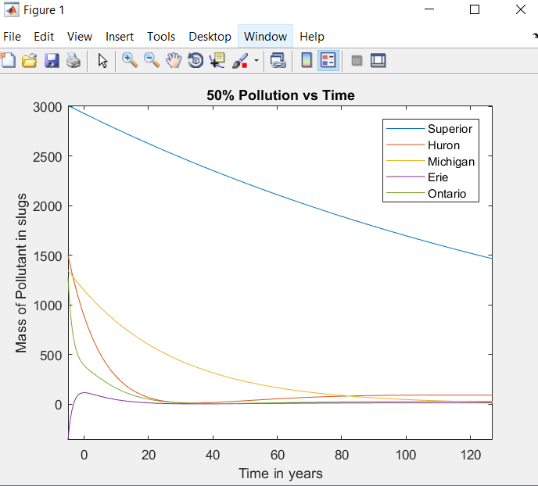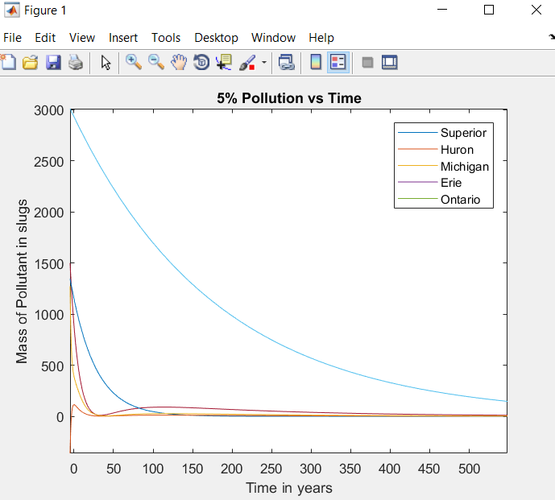

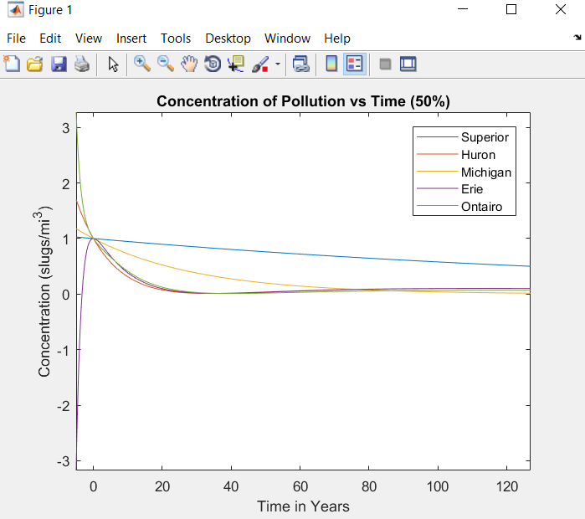
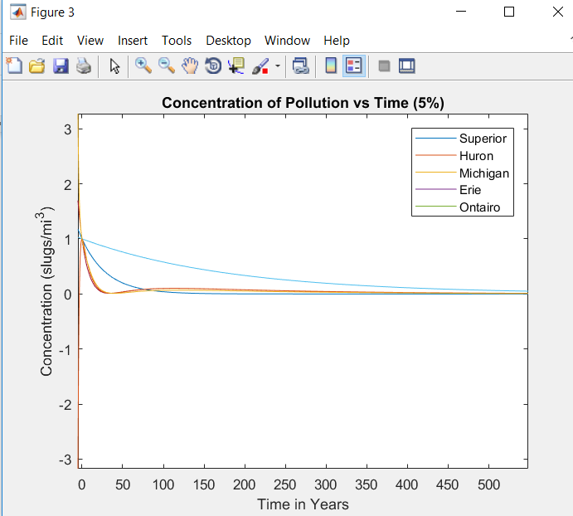

Citations:
Henricksen,​ ​Mel.​ ​“Coding​ ​Aids.”​ ​​Coding Aids, <https://wit.blackboard.com/bbcswebdav/pid-765291-dt-content-rid-3551319_1/courses/Merge_ MATH-2500_01_09.201810/Project%201%20-%20Coding%20aids-F17.pdf>

“Eqn.” Solve Equations Numerically - MATLAB Vpasolve, www.mathworks.com/help/symbolic/vpasolve.html?s_tid=doc_ta.

Matlab Code:
A=[-16/2929,0,0,0,0;16/2929,-75/884,-37/1145,0,0;0,0,-37/1145,0,0;0,75/884,0,-75/114,0;0,0,0,75/114,-111/389];
poly(A);
r=roots(poly(A));
I=eye(5,5);
%Eigen Vectors
r1=evalues(1) ;
r2=evalues(2);
r3=evalues(3);
r4=evalues(4);
r5=evalues(5);
%Eigen Values
u1=null(A-r1*I);
u2=null(A-r2*I);
u3=null(A-r3*I);
u4=null(A-r4*I);
u5=null(A-r5*I);
%Find the constants
B=[u1,u2,u3,u4,u5];
X0=[2929;884;1145;114;389];
C=inv(B)*X0;
%coefficients of eigenvalues for x1
r(1)
x11=C(1)*u1(1);
x12=C(2)*u2(1);
x13=C(3)*u3(1);
x14=C(4)*u4(1);
x15=C(5)*u5(1);
%coefficients of eigenvalues for x2
x21=C(1)*u1(2);

x22=C(2)*u2(2);
x23=C(3)*u3(2);
x24=C(4)*u4(2);
x25=C(5)*u5(2);
%coefficients of eigenvalues for x3
x31=C(1)*u1(3);
x32=C(2)*u2(3);
x33=C(3)*u3(3);
x34=C(4)*u4(3);
x35=C(5)*u5(3);
%coefficients of eigenvalues for x4
x41=C(1)*u1(4);
x42=C(2)*u2(4);
x43=C(3)*u3(4);
x44=C(4)*u4(4);
x45=C(5)*u5(4);
%coefficients of eigenvalues for x5
x51=C(1)*u1(5);
x52=C(2)*u2(5);
x53=C(3)*u3(5);
x54=C(4)*u4(5);
x55=C(5)*u5(5);
%make the eqautions with these calculated values. Some of these values are
%zero, these were used to get the simplified eqations in the report
equations=[x11,x12,x13,x14,x15;x21,x22,x23,x24,x25;x31,x32,x33,x34,x35;x41,x42,x43,x44,x45;x51,x52,x53,x54,x55];
%from the simplified equations we can simplifyu in terms of x and asign
%each equation a different variable, it will make things easier
syms t
s=x15*exp(r5*t);
h=x23*exp(r3*t)+x24*exp(r4*t)+x25*exp(r5*t);
m=x34*exp(r4*t);
e=x41*exp(r1*t)+x43*exp(r3*t)+x44*exp(r4*t)+x45*exp(r5*t);
o=x51*exp(r1*t)+x52*exp(r2*t)+x53*exp(r3*t)+x54*exp(r4*t)+x55*exp(r5*t);
%Time for lakes to get to 50% polution
Spol50 = vpasolve(0.5*X0(1)==s,t);
Hpol50 = vpasolve(0.5*X0(2)==h,t);
Mpol50 = vpasolve(0.5*X0(3)==m,t);
Epol50 = vpasolve(0.5*X0(4)==e,t);

Opol50 = vpasolve(0.5*X0(5)==o,t);
%Time for 5% polutant
Spol5 = vpasolve(0.05*X0(1)==s,t);
Hpol5 = vpasolve(0.05*X0(2)==h,t);
Mpol5 = vpasolve(0.05*X0(3)==m,t);
Epol5 = vpasolve(0.05*X0(4)==e,t);
Opol5 = vpasolve(0.05*X0(5)==o,t);
%Plots 50%
figure;
fplot(s);
hold on;
fplot(h);
hold on;
fplot(m);
hold on
fplot(e);
hold on;
fplot(o);
hold on;
plot(Spol50,2929/2,'r');
hold on;
plot(Hpol50,884/2,'b');
hold on
plot(Mpol50,1145/2,'g');
hold on;
plot(Epol50,114/2,'m');
hold on;
plot(Opol50,389/2,'k');
hold on
title("50% Pollution vs Time");
xlabel("Time in years");
ylabel("Mass of Pollutant in slugs");
legend('Superior','Huron','Michigan','Erie','Ontario');
%Plots 5%
figure;
fplot(s);
hold on;
fplot(h);
hold on;
fplot(m);

hold on
fplot(e);
hold on;
fplot(o);
hold on;
plot(Spol5,2929/20,'r');
hold on;
plot(Hpol5,884/20,'b');
hold on;
plot(Mpol5,1145/20,'g');
hold on;
plot(Epol5,114/20,'m');
hold on;
plot(Opol5,389/20,'k');
hold on
title("5% Pollution vs Time");
xlabel("Time in years");
ylabel("Mass of Pollutant in slugs");
legend('Superior','Huron','Michigan','Erie','Ontario');
%Concentration 50%
figure;
fplot(s/X0(1));
hold on;
fplot(h/X0(2));
hold on;
fplot(m/X0(3));
hold on;
fplot(e/X0(4));
hold on;
fplot(o/X0(5));
hold on;
plot(Spol50,0.5,'r');
hold on;
plot(Hpol50,0.5,'b');
hold on;
plot(Mpol50,0.5,'g');
hold on;
plot(Epol50,0.5,'m');
hold on;
plot(Opol50,0.5,'k');

hold on;
title("Concentration of Pollution vs Time (50%)");
xlabel("Time in Years");
ylabel("Concentration (slugs/mi^3)");
legend('Superior','Huron','Michigan','Erie','Ontairo');
%Concentration 5%
fplot(s/X0(1));
hold on;
fplot(h/X0(2));
hold on;
fplot(m/X0(3));
hold on;
fplot(e/X0(4));
hold on;
fplot(o/X0(5));
hold on;
plot(Spol5,.05,'r');
hold on;
plot(Hpol5,.05,'b');
hold on;
plot(Mpol5,.05,'g');
hold on;
plot(Epol5,.05,'m');
hold on;
plot(Opol5,.05,'k');
hold on;
title("Concentration of Pollution vs Time (5%)");
xlabel("Time in Years");
ylabel("Concentration (slugs/mi^3)");
legend('Superior','Huron','Michigan','Erie','Ontario');

